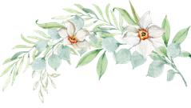
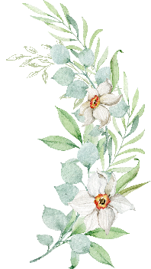
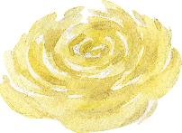
2023 Chautauqua Flower Show Categories
Category I: Artistic Arrangements: Should be presented in containers or with accessories.

Foliage only
Dining Table
Wild Flowers
Small, 5-8 inches
Smaller, 3-5 inches
Tiny, 1-3 inches
Roses
Wooden/Basket Container
Dried Material
Category II: Herbs: Should be presented in a plain container with no bloom.

Mint Catnip Basil
Thyme
Hyssop Parsley
Dill Oregano
Calendula Yarrow Comfrey Echinacea
Columbine Rosemary
Wild Marjoram
Lavender
Sage

Category III: Horticulture: Any potted plant

Double Fern Geranium Snake Plant Begonia Mixed Cactus
Sage
Palm Shamrock
Lemon Tree Orchid Evergreen Philodendron Jade Plant
Hens and Chicks Coleus
Aloe
African Violet
African Violet, Ruffle
African Violet, Single
African Violet, Variegated
Creeping Fig (Ficus)
Artheriam Bonsai Prayer Plant

Category IV: Specimen: A single specimen presented in a plain container with little/no foliage

Spiderwort
Azalea
Bachelor buttons Butterfly Bush Mullein
Hibiscus Cleome Salvia
Lily, Asiatic Hybrid
Daisy Aster
Bee Balm Geranium Campanula Osteosperum Hydrangea Coreopsis
Lily, Calla
Larkspur
Evening Primrose Sweet William Delphinium Magnolia
Clematis
St. Jon’s Wort Lantana
Lily, Day
Snapdragon False Sunflower Babies Breath Gaillardia
Cali canthus Nasturtium Honey Suckle Coral Bells Sedum
Lily, Oriental
Allium Statice Feverfew
Love in the Mist Gerbera Daisy Carnation
Rose Lambs Ear

Please note: More categories may be added as needed.

